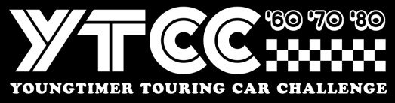
Stichting Youngtimer Touring Car Challenge
Invoice number / DijonYTCC/BRCC 2023 + Name driver
Event Dijon Motors Cup 2023
__________________________________________________________________________
Colmore YTCC and BRCC Dijon 6-8 October
2x 25” qualification + 6 x 25/30” minute races 1300

____________________________________________________________________________
Total EURO 1300

Payment towards
IBAN : NL 44 INGB 0006 7911 68
BIC : INGB NL2A att: Stg Youngtimer Touring Car Challenge
Stichting Youngtimer Touring Car Challenge, Remmerdenplein 9, 1106AD Amsterdam
Kamer van Koophandel 62904078

