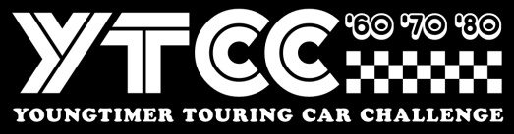
Stichting Youngtimer Touring Car Challenge
Invoice number / ASSEN Finale races + Name driver
Event Finale Races Assen October
__________________________________________________________________________
Colmore YTCC + BRCC + Nineties + Sports
1x 25” qualification + 3 x 25” minute races 395,00

____________________________________________________________________________
Total EURO 395,00

Payment towards
IBAN : NL 44 INGB 0006 7911 68
BIC : INGB NL2A att: Stg Youngtimer Touring Car Challenge
Stichting Youngtimer Touring Car Challenge, Remmerdenplein 9, 1106AD Amsterdam
Kamer van Koophandel 62904078

