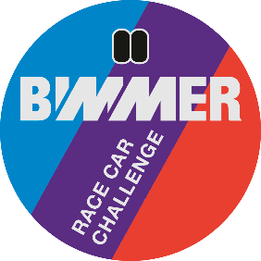
Stichting Youngtimer Touring Car Challenge
Invoice number / Oschersleben BRCC + Name driver
Event Grosse Preis der Stadt Magdeburg
__________________________________________________________________________
Bimmer Race Car Challenge
1x 25” qualification + 3 x 30” minute races 675,00

____________________________________________________________________________
Total EURO 675,00
If you pay before 1/2/2023 600,00

Payment towards
IBAN : NL 44 INGB 0006 7911 68
BIC : INGB NL2A att: Stg Youngtimer Touring Car Challenge
Stichting Youngtimer Touring Car Challenge, Remmerdenplein 9, 1106AD Amsterdam
Kamer van Koophandel 62904078

