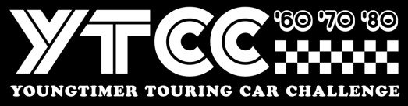
Stichting Youngtimer Touring Car Challenge
Invoice number / Dijon2023 + Name driver
Event Dijon Motors Cup 2023
__________________________________________________________________________
Sports class YTCC
Dijon 6-8 October
1x 25” qualification + 3 x 25” minute races 850,00

____________________________________________________________________________
Total EURO 850,00

Payment towards
IBAN : NL 44 INGB 0006 7911 68
BIC : INGB NL2A att: Stg Youngtimer Touring Car Challenge
Stichting Youngtimer Touring Car Challenge, Remmerdenplein 9, 1106AD Amsterdam
Kamer van Koophandel 62904078

