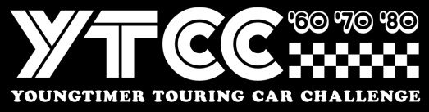
Stichting Youngtimer Touring Car Challenge
Invoice number / SPASC2023 + Name driver
Event Spa Summer Classic YTCC 2023
__________________________________________________________________________
Colmore YTCC Spa Summer Classic 2023
1x 25” qualification + 3 x 30” minute races 850,00

____________________________________________________________________________
Total EURO 850,00
Payment before 1st February 2023 795,00

Payment towards
IBAN : NL 44 INGB 0006 7911 68
BIC : INGB NL2A att: Stg Youngtimer Touring Car Challenge
Stichting Youngtimer Touring Car Challenge, Remmerdenplein 9, 1106AD Amsterdam
Kamer van Koophandel 62904078

