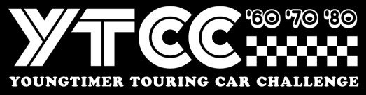
Stichting Youngtimer Touring Car Challenge
Invoice number / BH2020 + Name driver
Event Brands Hatch Masters 2020 – 23/24 May 2020
To: ……………………………………………………………………………… /……………………………………………………..
__________________________________________________________________________
YTCC Brands Hatch 23/24 May 2020
1x 25” qualification + 2 x 30” minute races 800,00

____________________________________________________________________________
Total EURO 800,00

Payment towards
IBAN : NL 44 INGB 0006 7911 68
BIC : INGB NL2A att: Stg Youngtimer Touring Car Challenge
Payment must be done before 10th April 2020
Stichting Youngtimer Touring Car Challenge, Remmerdenplein 9, 1106AD Amsterdam
Kamer van Koophandel 62904078

